Interview Management System

BY:-

Rahul Tuteja

Description:

An **Interview Management System** is a software application that enables the electronic handling of recruitment and hiring needs. An ATS can be implemented or accessed online at enterprise- or small-business levels, depending on the needs of the organization. The company can use this software to assist with human resources, recruitment, and hiring needs. While each system offers a different package of features, these kind of systems are primarily used to help hiring companies organize and navigate large numbers of application.

Technologies Used:

Front-end:- Html, CSS, Angular.js

Back-end: - Node.js

Database: - Mongo DB

Modules:

**Admin: -**

1. The main person who will controlling most of the things he can be referred to recruiter.
2. Admin can add new department for the company i.e. Management, Tech., HR, etc.
3. He can introduce new posts to each department.
4. He can add interviewers for each post.
5. He will add the job opportunities for the applicant.
6. He will schedule all the interviews for applicant and assign the interviewers.
7. In the he will be the one who will recruit the applicant or not.

**Applicant: -**

1. Any new applicant can sign up on the web site.
2. Applicant can view through the job opportunities for which he is eligible.
3. He can apply for any job for which he is eligible.
4. He can see status for his upcoming interview.
5. He will get the status of his last interview i.e. whether he have been selected for the job or not.

**Interviewer: -**

He will get the details for his next interview.

1. He can reject to take the interview.
2. He will send the comments about the interview he has taken

**E.R. Diagram** used for the database:-

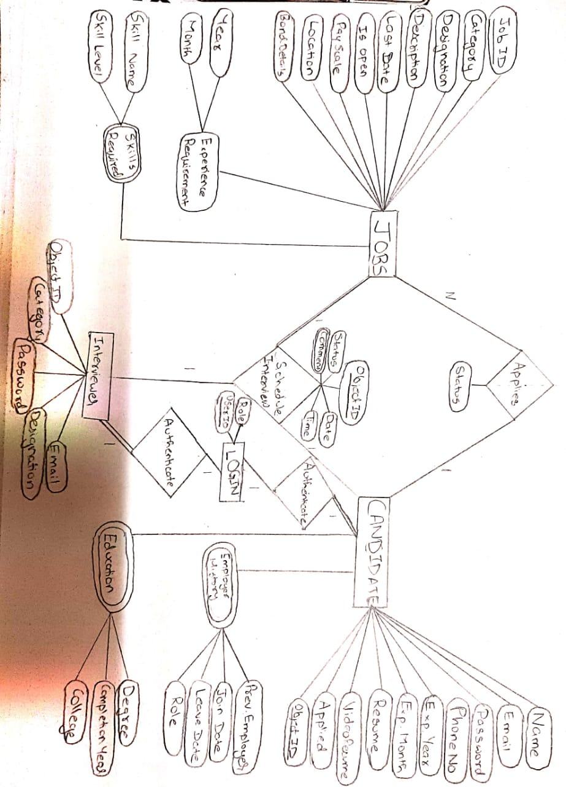

**How to start the front-end**

## Development server

Run `ng serve` for a dev server. Navigate to `http://localhost:4200/`. The app will automatically reload if you change any of the source files.

## Code scaffolding

Run `ng generate component component-name` to generate a new component. You can also use `ng generate directive|pipe|service|class|guard|interface|enum|module`.

## Build

Run `ng build` to build the project. The build artifacts will be stored in the `dist/` directory. Use the `--prod` flag for a production build.

## Running unit tests

Run `ng test` to execute the unit tests via [Karma](https://karma-runner.github.io).

## Running end-to-end tests

i `ng e2e` to execute the end-to-end tests via [Protractor](<http://www.protractortest.org/>).

**Run ‘npm start’ to start the back-end**

**Start the mongodb server on port 27017.**